CYBER SECURITY- VIRTUALIZATION AND CLOUD BASICS

GOOGLE HACKING TECHNIQUE
TASK1: Use Google search operators to find publicly accessible PDF files about IPL cricket rules. List the exact search query you used and share 3 working links you found.
USE QUERY :
"IPL" "playing conditions" filetype:pdf OR "IPL" "rules" filetype:pdf
Working Links
1. IPL Official Documents
IPL Official Documents 
The IPL's official documents page includes Match Playing Conditions, Code of Conduct and other regulations.
2. ICC Playing Conditions PDF
ICC Playing Conditions PDF 
This is an official ICC PDF containing cricket playing conditions and rules.
3. ICC Men's T20 Playing Conditions PDF
ICC Men's T20 International Playing Conditions 
This PDF describes T20 playing conditions, including the match, players, equipment, playing area and other rules.

TASK2: Search for login pages of Zomato by using Google dorking techniques. Write the search query you used and explain why it works.<br><br><em><strong>Hint:</strong> Try using 'inurl:login site:zomato.com'.</em>
SEARCH: inurl:login site:zomato.com
There are two important operators:
site:zomato.com
This tells Google to show results from the Zomato domain.
inurl:login
This asks Google to look for pages where the URL contains the word login.
So: inurl:login site:zomato.com
Example of a Legitimate Zomato Login Page
Zomato has publicly accessible login-related pages. For example, its merchant login page is:
Zomato Merchant Login 
Zomato also has a restaurant-partner dashboard with a login function.
Important Security Point
Finding a login page through Google does not mean the page is vulnerable. A login page is normally intended to be publicly reachable.
The security concern would arise if the page exposed things such as:
- passwords
- API keys
- internal information
- configuration files
- administrator functions without proper authentication
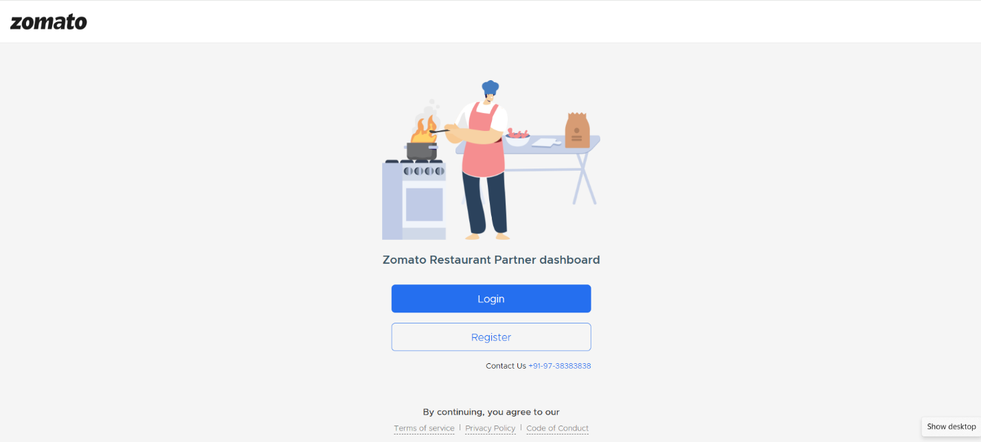

TASK3:
Find exposed Excel files containing the word 'playlist' from Spotify-related domains using Google hacking methods. Share your search query and one result (URL) you found.
SEARCH: site:spotify.com playlist filetype:xlsx
Operator | Meaning
site:spotify.com | Limits results to Spotify's domain
playlist | Searches for the word "playlist"
filetype:xlsx | Searches for Excel .xlsx files
filetype:xls | Searches for older Excel .xls files

NO RESEULT WAS FOUND USING THIS QUESRY
"The search was performed using the site:, filetype: and keyword operators. No suitable publicly indexed Excel file was found in my search."
TASK4: Identify possible exposed admin panels for any Indian e-commerce site (like Flipkart or Myntra) using Google hacking. Write the dork you used and explain what makes such panels risky if left open.<br><br><em><strong>Hint:</strong> Use 'intitle:admin site:flipkart.com' or similar.</em>
Safe Demonstration Query
intitle:admin site:flipkart.com
Searches for pages where admin appears in the page title.
site:flipkart.com
Why Can Admin Panels Be Risky?
An administrative panel may provide powerful functions such as:
- managing website content
- managing users
- changing settings
- viewing business information
- managing orders or other internal functions
If an administrative interface is incorrectly configured or lacks proper authentication, unauthorized people could potentially access functions they should not have.
However, simply finding an admin page in Google does not prove that it is vulnerable.

